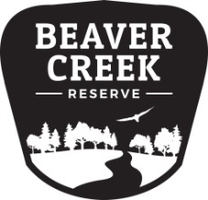
Beaver Creek Reserve
2022 Amateur Nature Photo Contest

Please complete the following information for each photo entry. Limit of 5 photograph entries with no more than 2 per category. Include photo releases for People Connecting with Nature category.

Name |  | Phone #
Email
Address
City | State |  | ZIP Code
Category: | Division:
Title:
Location of Photo:
NOTE: Entering the contest gives Beaver Creek Reserve the right to royalty-free reproduction of photography for use in marketing, social media, display, and fundraising, including sale of the Nature Calendar.

Beaver Creek Reserve
2022 Amateur Nature Photo Contest
Name |  | Phone #
Email

Address
City | State |  | ZIP Code
Category: | Division:
Title:
Location of Photo:

Please complete the following information for each photo entry. Limit of 5 photograph entries, with no more than 2 per category. Include photo releases for People Connecting with Nature category.
NOTE: Entering the contest gives Beaver Creek Reserve the right to royalty-free reproduction of photography for use in marketing, social media, display, and fundraising, including sale of the Nature Calendar.

